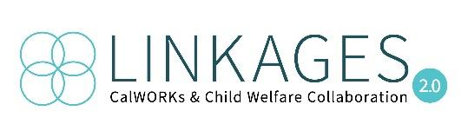 | Coordinated Case Planning: Peer Conversations  Breakout Questions  Collaboration Breakout

- What are your successes in this area?
NOTES:
Mendocino - Provided training to Child Welfare - got the conversation going. Now we send an email when we find out there is a shared case. Foster Care eligibility worker will send info. This has led to sharing of case plans. Case plan is important - not asking families to do more while they are in crisis.
Nevada - seasoned staff in the roles. Virtual meetings started happening more often during Covid. This started the improvement of communication. Linkages meetings twice a month. Joint home visits. Getting together more often than once a month has been more helpful. Structure of meetings - excel spreadsheet of shared families. Supervisors from both sides attend. Review spreadsheet. WTW person brings everyone up to speed on family status of needs and what has been done. Review accomplishments, court dates, CFT meeting dates. Workers from both sides are talking to each other. Universal ROI done by county counsel. Most get FR pre-dispo. Get initial case plan, then after dispo get update case plan. Communication and coordination with Rapid Response.
Trinity - notified by child welfare when a child is removed for possible Linkages. Meet monthly or more often if needed. Foster Care eligibility worker is co-located so we can talk easily. Share case plan. Enroll in family stabilization. Housing support. Communication is successful. Case plan - if CWS doesn’t have a case plan yet, they’ve discussion of general idea of services they will be looking at so can get them enrolled. Then get the case plan once developed.
Santa Barbara County - have all together in same department.

- Where are your greatest challenges in this area?
NOTES:
Trinity county is smaller and doesn’t have a lot of resources. Example - no homeless shelter. What do counties do?
Imperial - refer right away to eligibility THA/HSP

- What have you tried? What worked, and what didn't?
NOTES:
Tracking successes
Nevada - CWS are tracking when reunified (analyst). CalSAWs does not work as a tracking tool.
Collaboration through turnover
Nevada - training CWS. Twice a year, PPT updates to remind folks of Linkages and what can be offered.

- What questions do you still have in this area?
NOTES:
How are counties tracking successes?
How do you continue the collaboration? Especially when turnover

